<https://docs.chef.io/>

<https://learn.chef.io/tutorials/>



Chef server cannot be installed on a windows machine. Your **chef server should always a 64-bit Linux machine only** and your chef client can be on any platform.

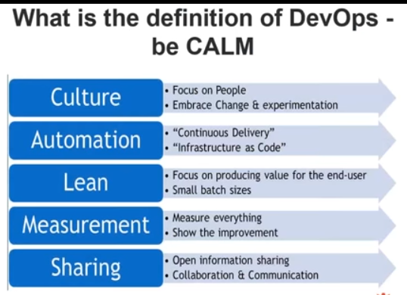

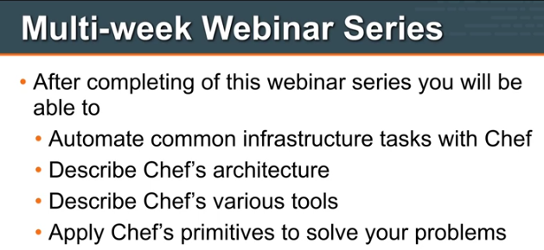

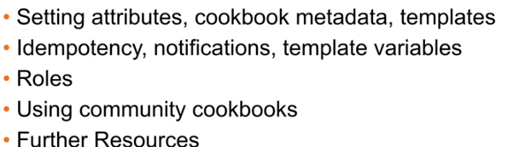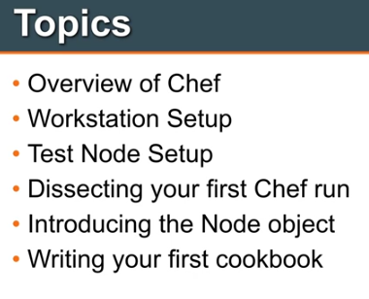

**DAY-1**

**Introduction to Chef:**

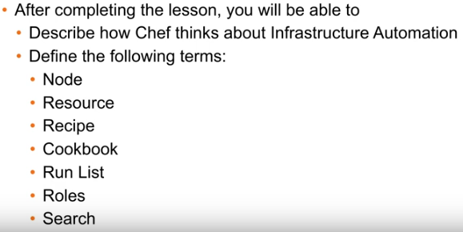

**RESOURCES:**

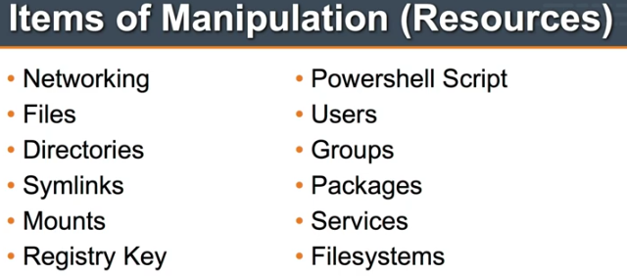

Complexity:

Initailly,we install and configure application on single node,like laptop.

He may have to do:

Install pkgs

Config.

Manage DB

1.)Application

2.) DB

3.) Make DB redundant..As we don’t want to lose data

4.) Make Application also reduntant …To prevent loss of failure and data

5.) Add load balancer…For request to be evenly distributed across infra.

6.) WebScale….Application grown bigger &Bigger…Now go for webscale

7.)DB Cache ---DB not keeping up demands wit Users

Each Infra. Has its own topology.

There are connections b/w load balancer and Appl.

Load balancer should know which application should talk to..,Which appli. They sud be sending requests t0…

Appli. Server intern need to know about DB.

DB cache servers need to know of Backend DB caches…Which data should be caching…

All these layers complexity…………

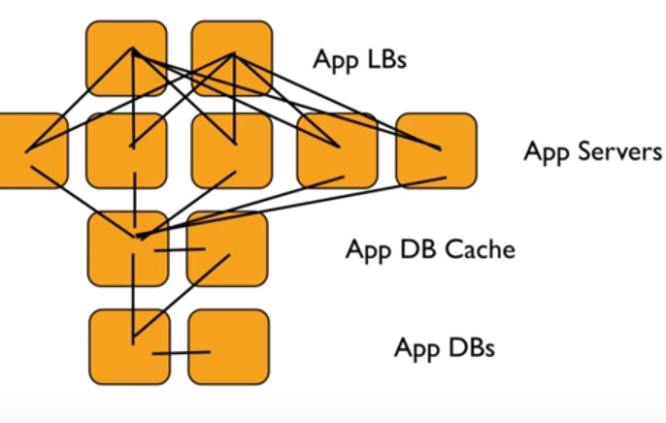

Our infra. Doesn’t looks like this at all…

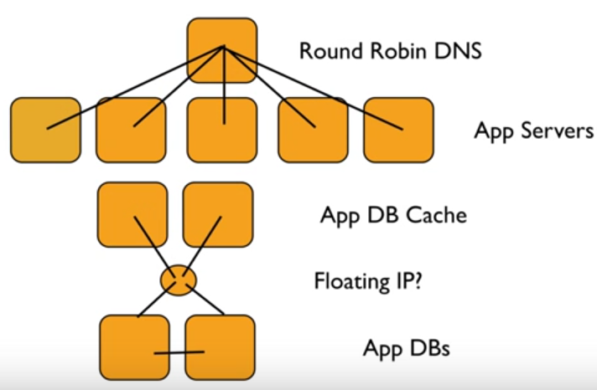

**Frankly doesn’t care how ur infra looks like…**

**Even Chef either cares…**

What Chef does is??????? Gives Tools to model infrastructure within Chef within Code…

Complexity increasessssss…..Chef solves the problem..

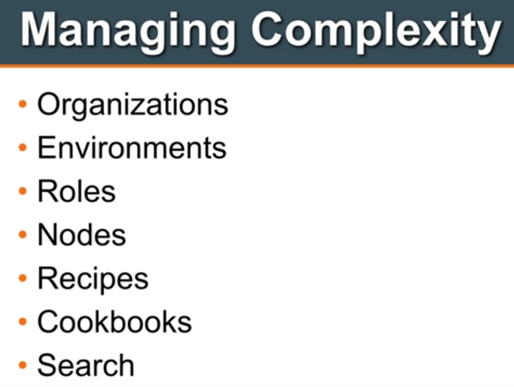

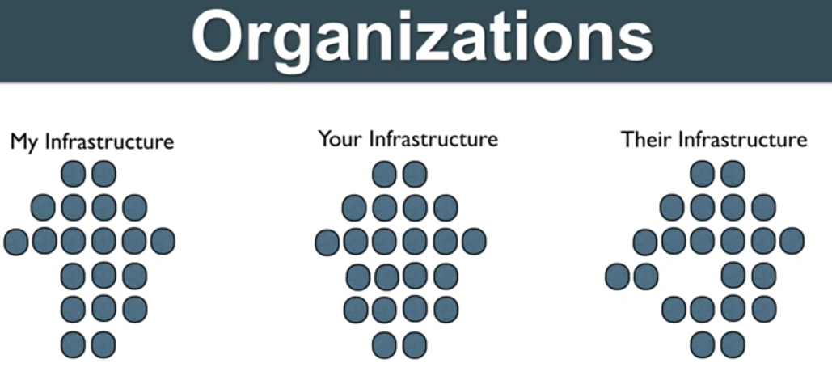

Organizations are independent tenants on enterprise chef.

2 types

Hosted:

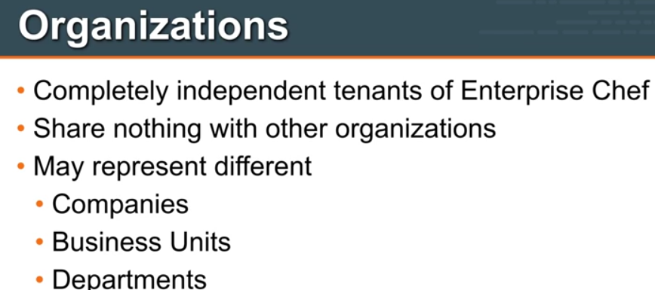

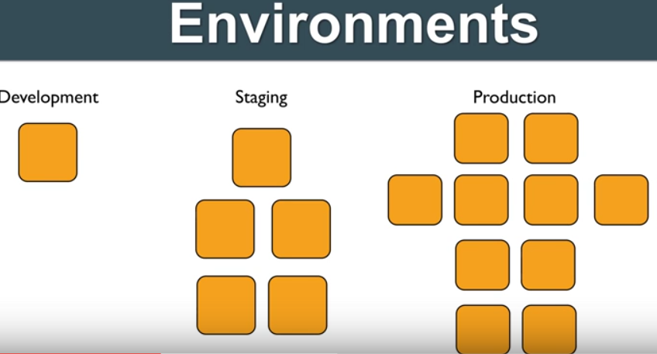

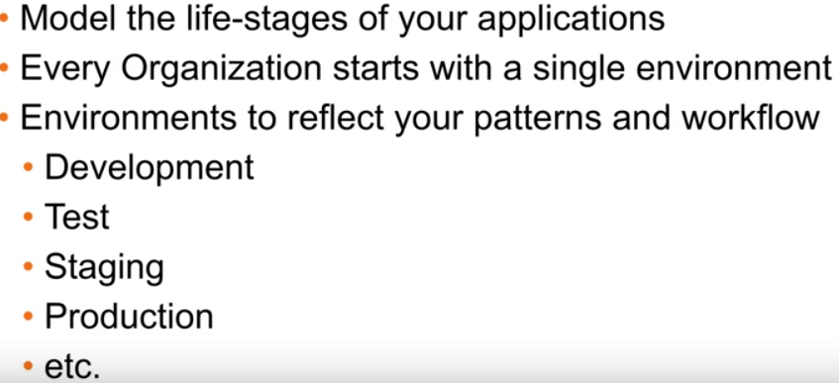

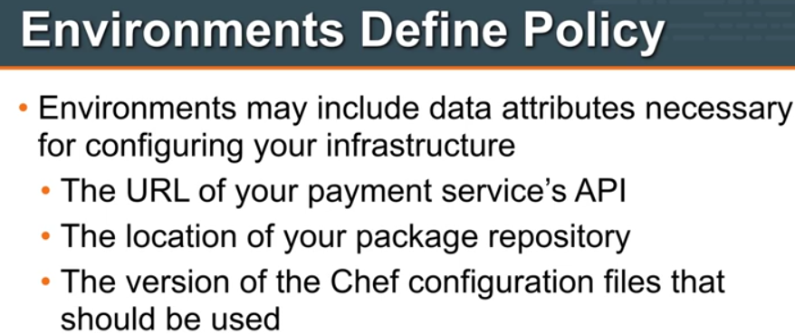

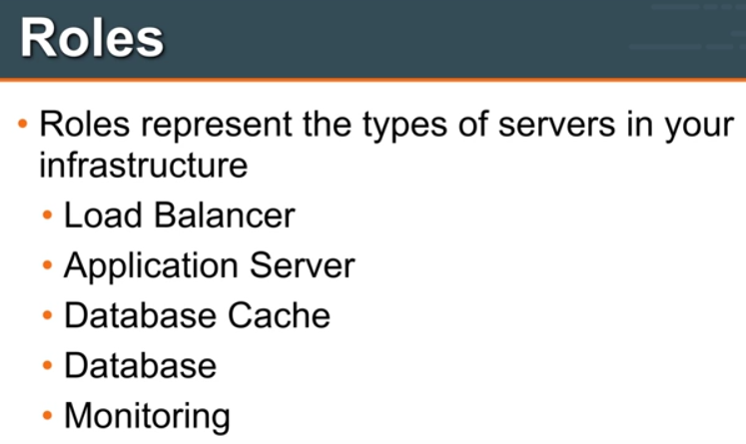

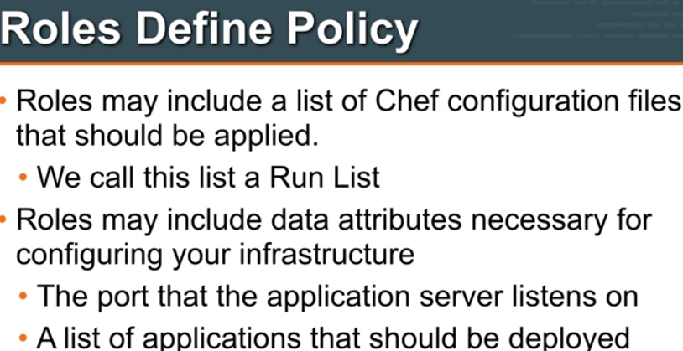

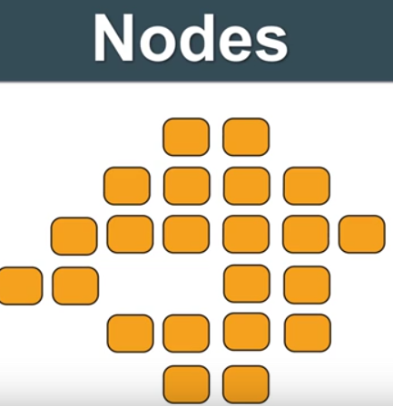

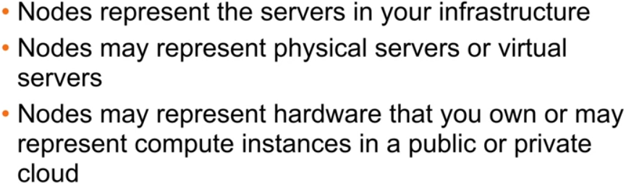

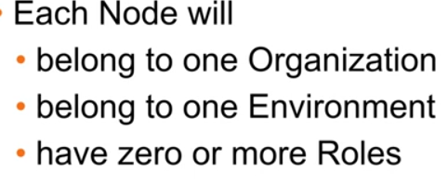

This node belongs my company. U don’t have access And vice-versa.

Server in DEV/QA/Stage

Node can be DB/APP server.. May be both roles.

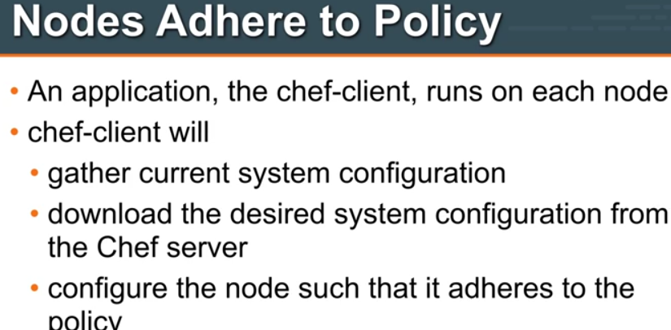

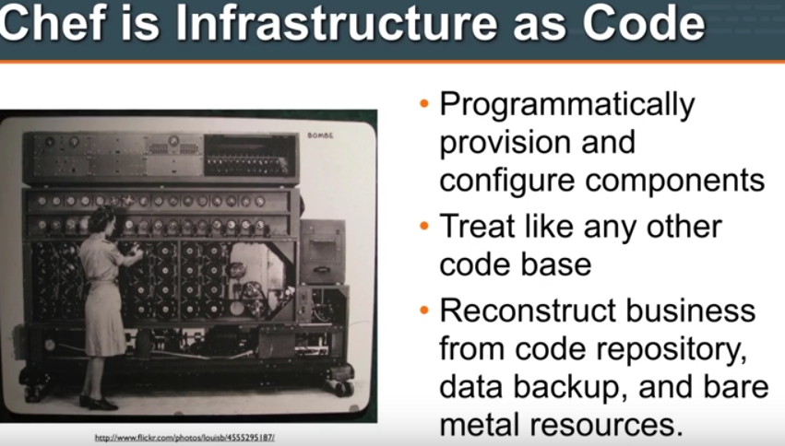

**With these simple things….I Can rebuild my application**

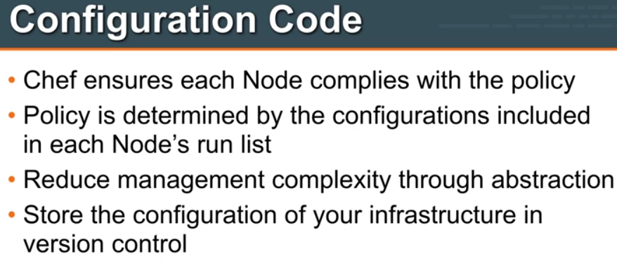

**Gone are the days.., servers are handcrafted by Sysadmin.**

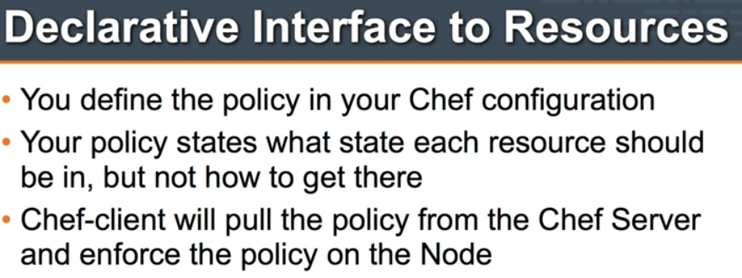**for Redhat---Yum**

**Ubuntu ---Apt-get**

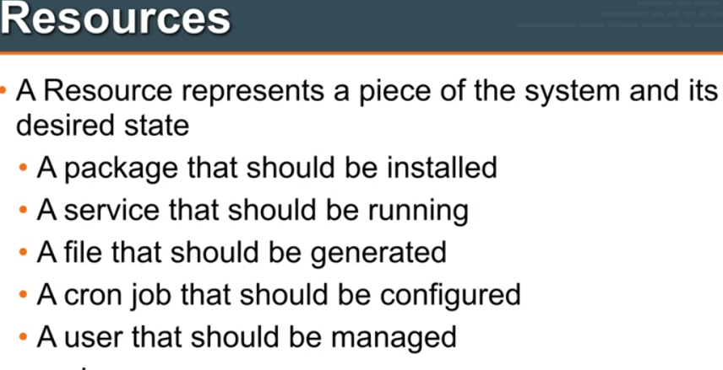 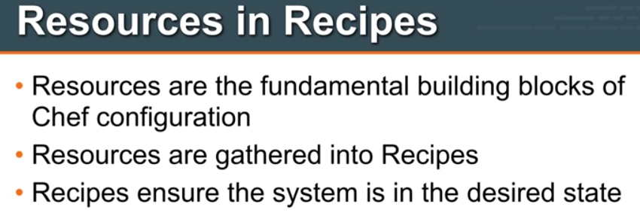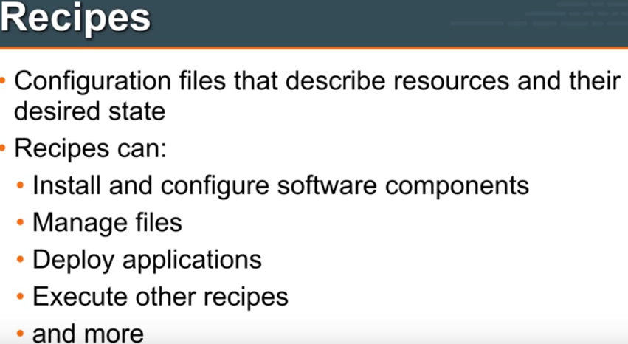

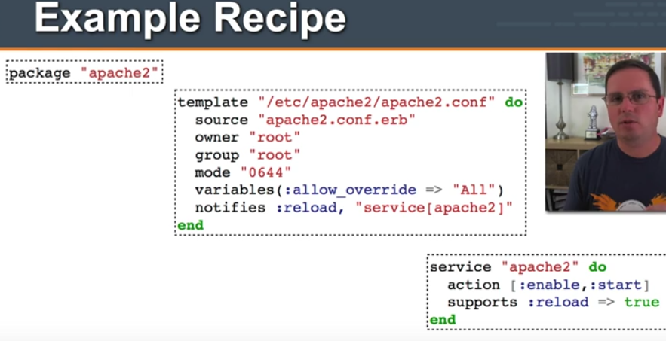

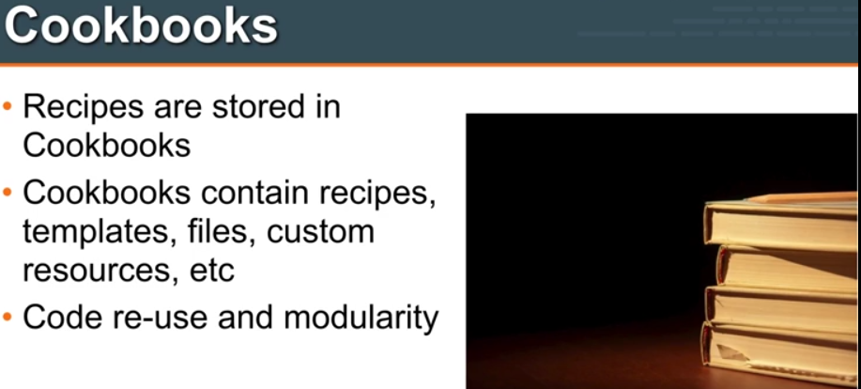

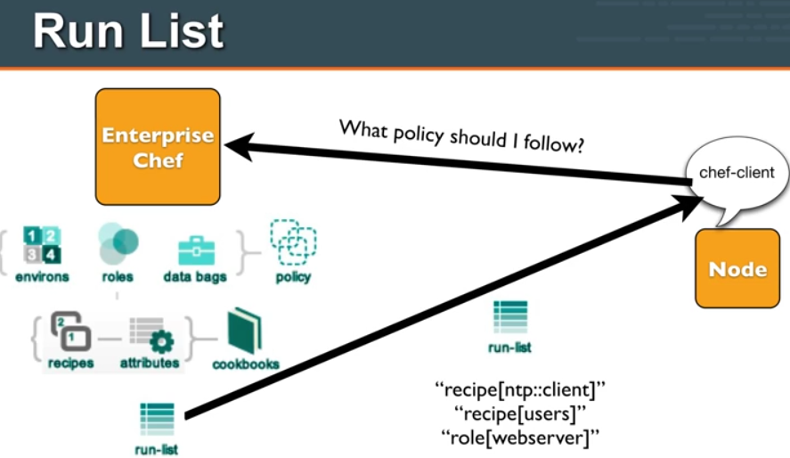

Like every 30 min

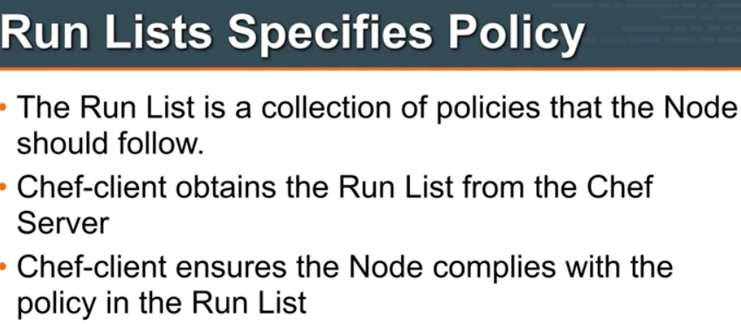

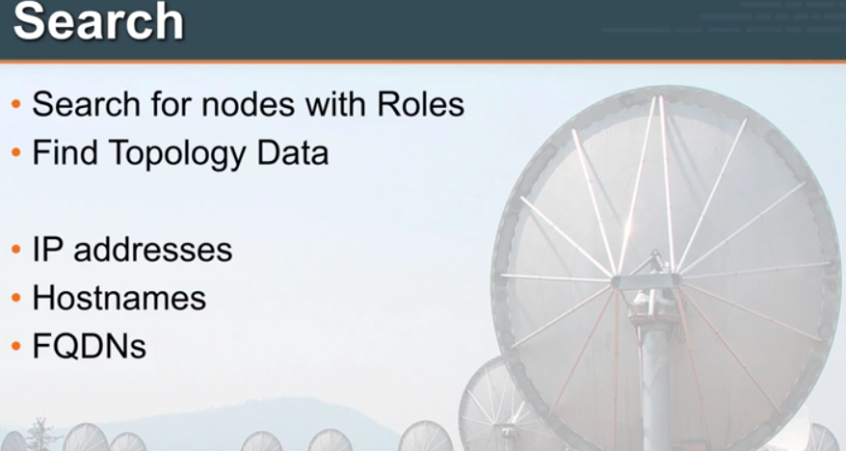

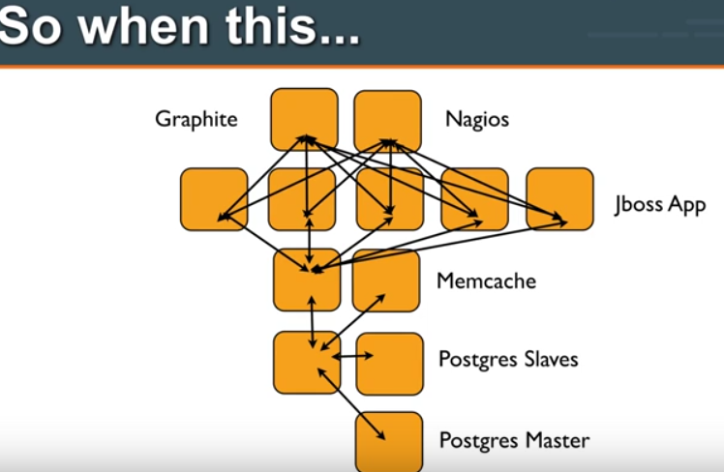

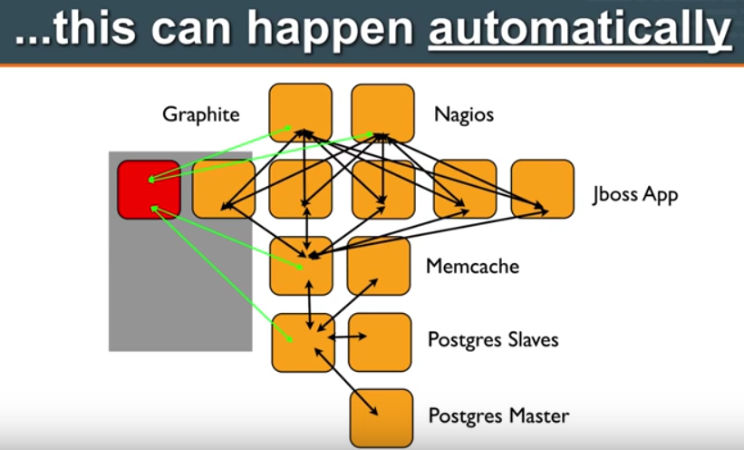

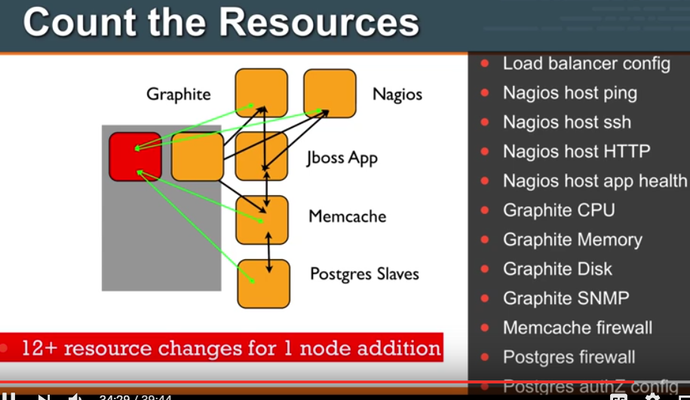

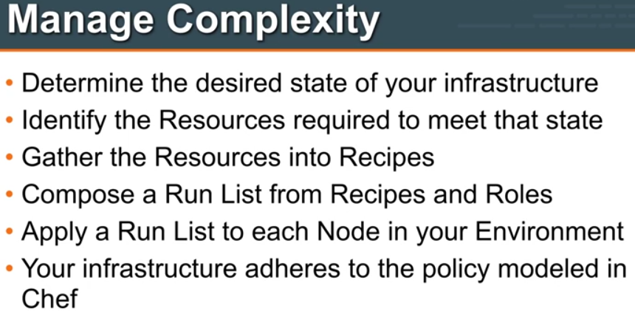

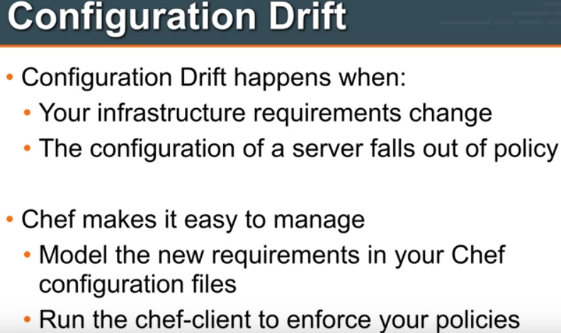

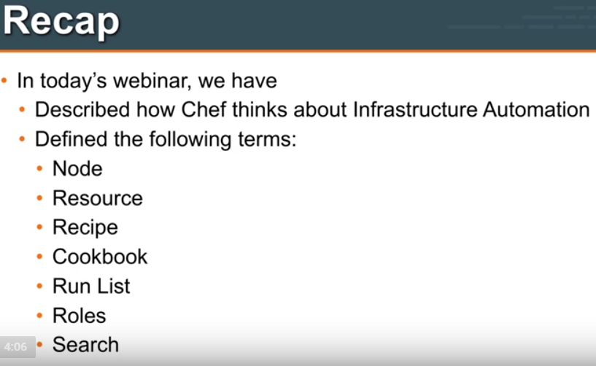

**Node:**Node is a component in ur infra..,such as a server…Physical or Compute instance running in cloud

**Resource:** Primitive building blocks within your Infra.Defines defines a component and its desired will store those in

Pkg to be installed

File to be managed

User to be managed

**Recipe**: Collection of resources..

Resources help to define Policy that should be applied to given infrA components of a node/server

**Coockbook:** Packaging Up of multiple recipes and other related files…Such as template files in same cookbook with the recipe And then will use thios cookbook as a distribution mechanism

We can use CB as building blocks..and can distribute CB to various nodes in our infra..

**Runlist:** Marrying on policy and node..

Which of my policies this node adhere to ….we sort by looking at runlist….

**Runlist** specifies these are policies for this particular node…

**A role** : Way of classifying ur servers…Diff. types of servers that u have in ur infra…

DB server role

-App. Server role

**Search:** Chef’s killer feature to help manage of ur infra.and do lots of other interesting

Which my monitoring server should look after…

I can execute some searches to find out answer to my Que…Which appli. Server should my load Balancer send requests to…

I will use search capability within Chef to answer my Question

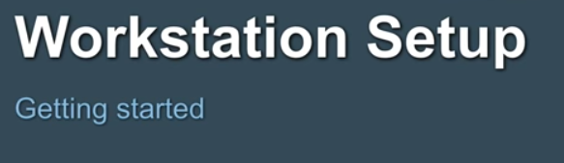

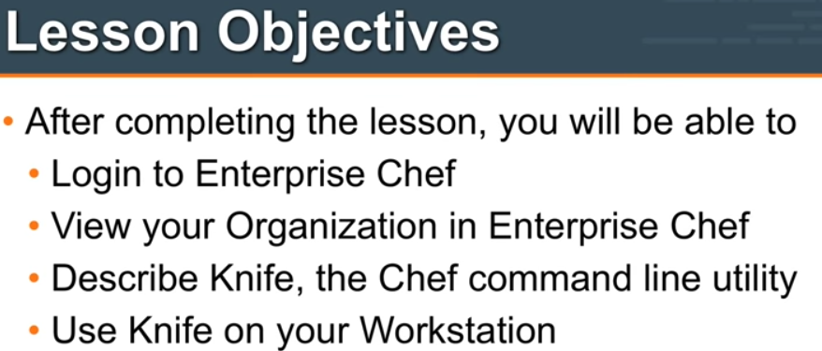

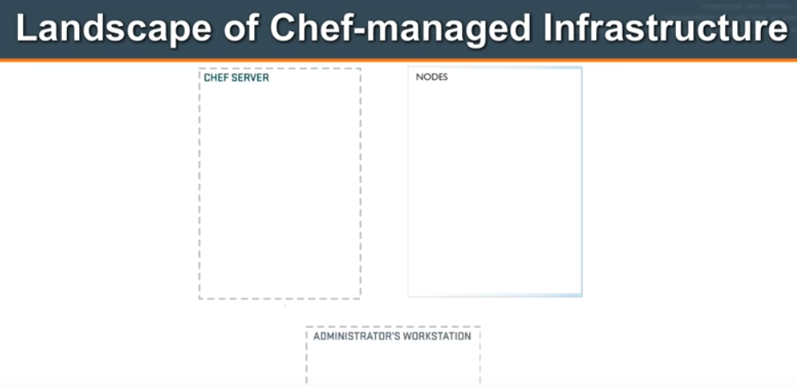

Chef-Server: All config Policies.Also info of nodes.

Admin Workstation: Where u interact with ur infra..and Chef-server

Nodes: m/c managed by chef

<https://downloads.chef.io/chef>

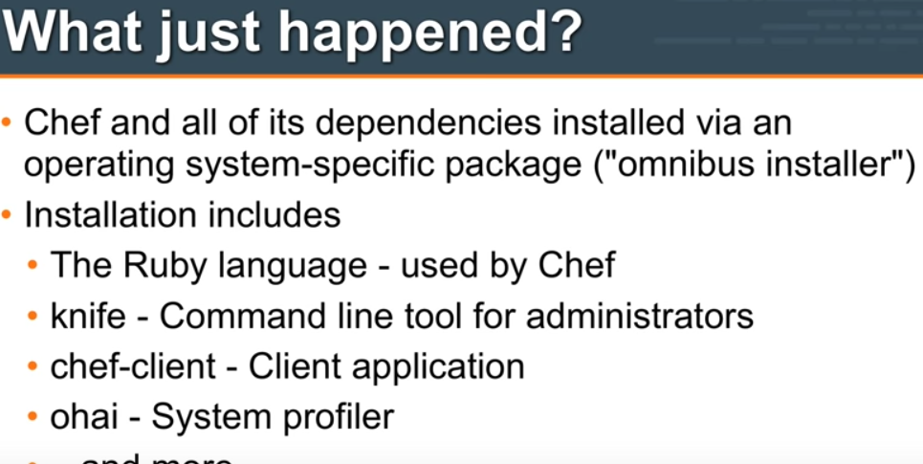

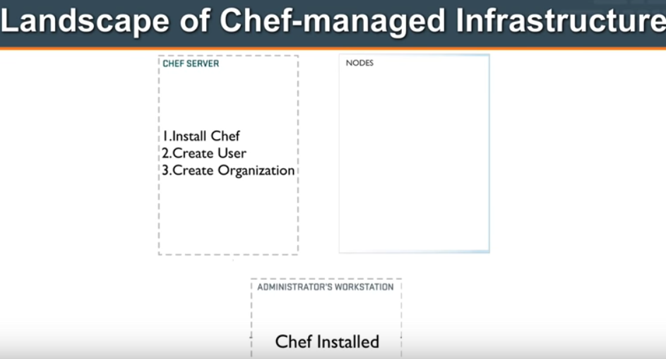

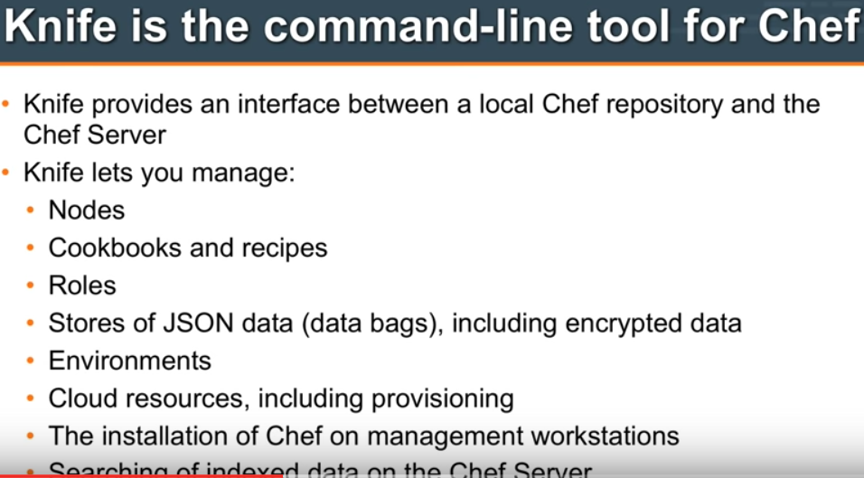



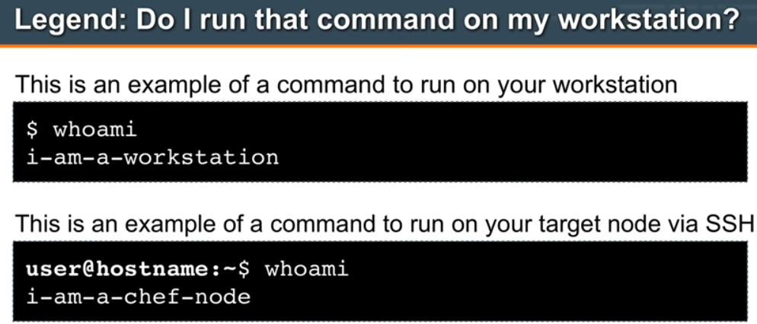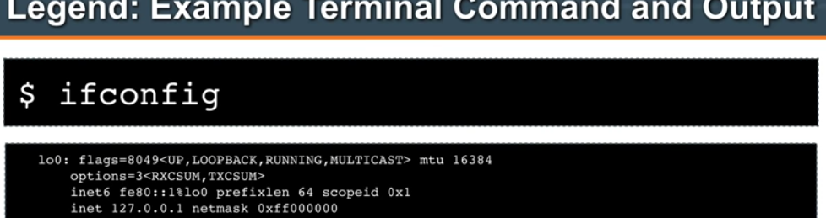

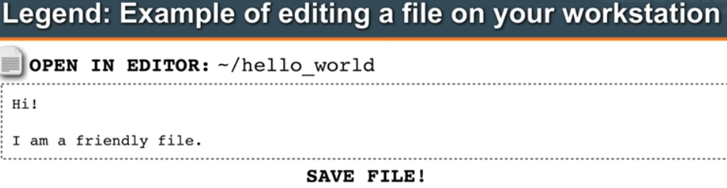

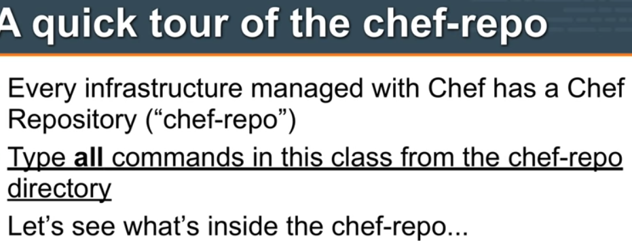

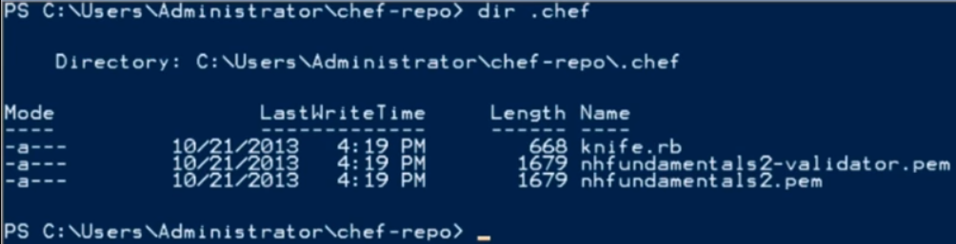

KNIFE.rb

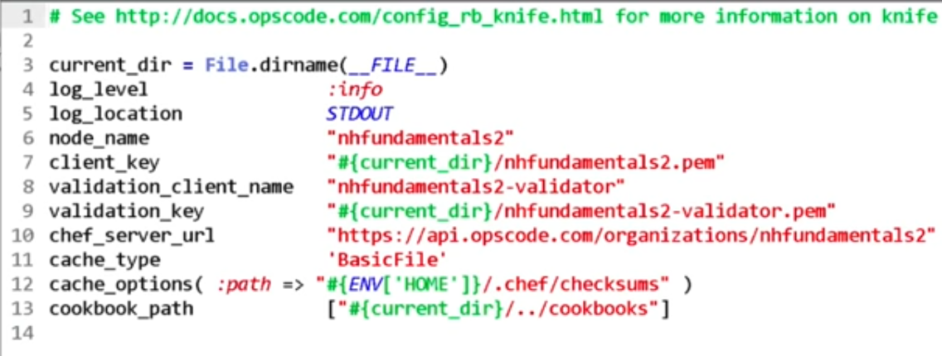

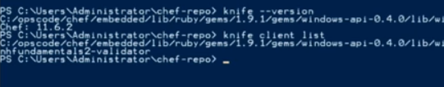

In Linux:

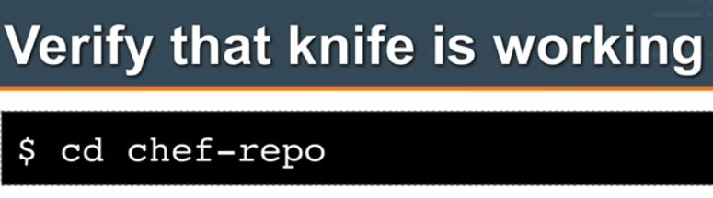

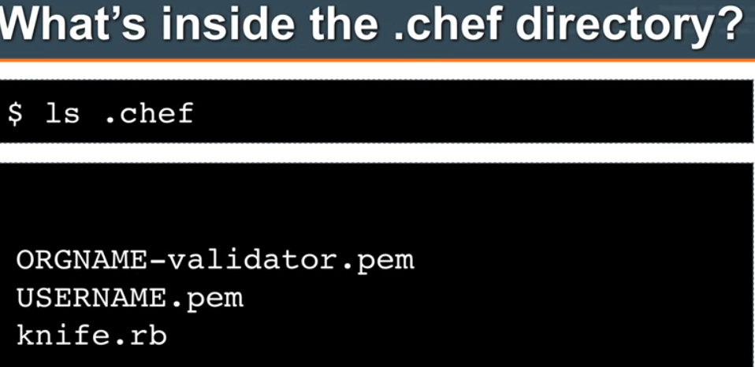

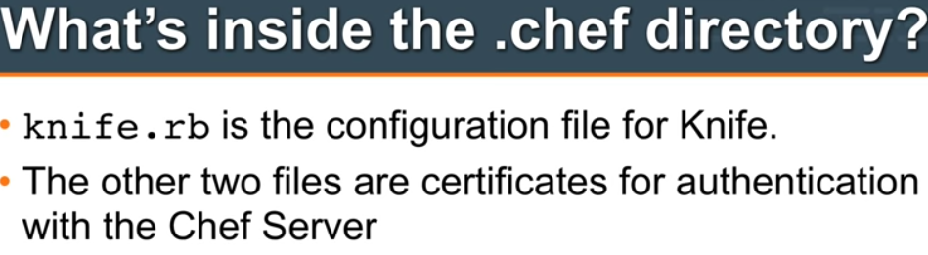

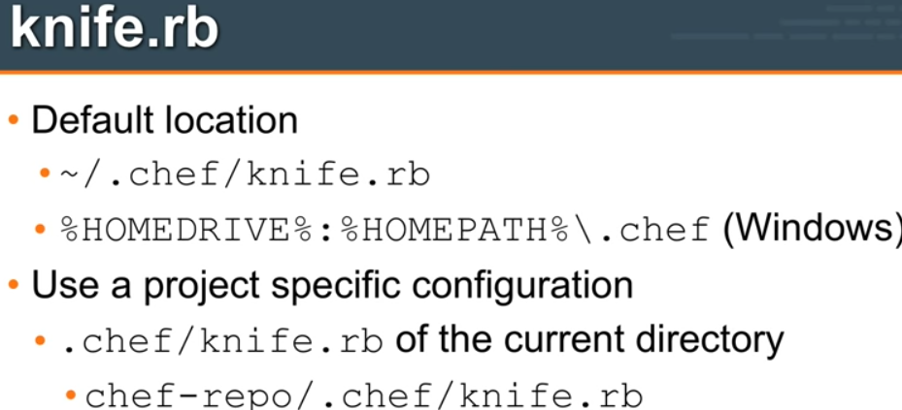

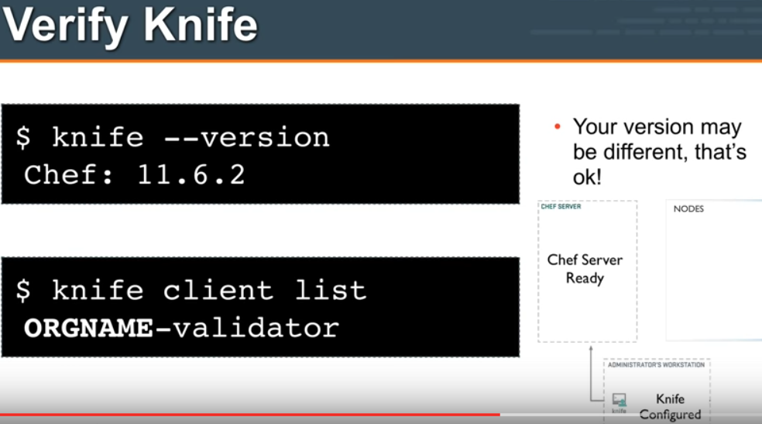

READ THISSSSSSSSSSSSSSSSSSSSSSSSSSSSSSSSSSSSSSSSSSSSSSSSSSSSSSSSSSSSSSSSS

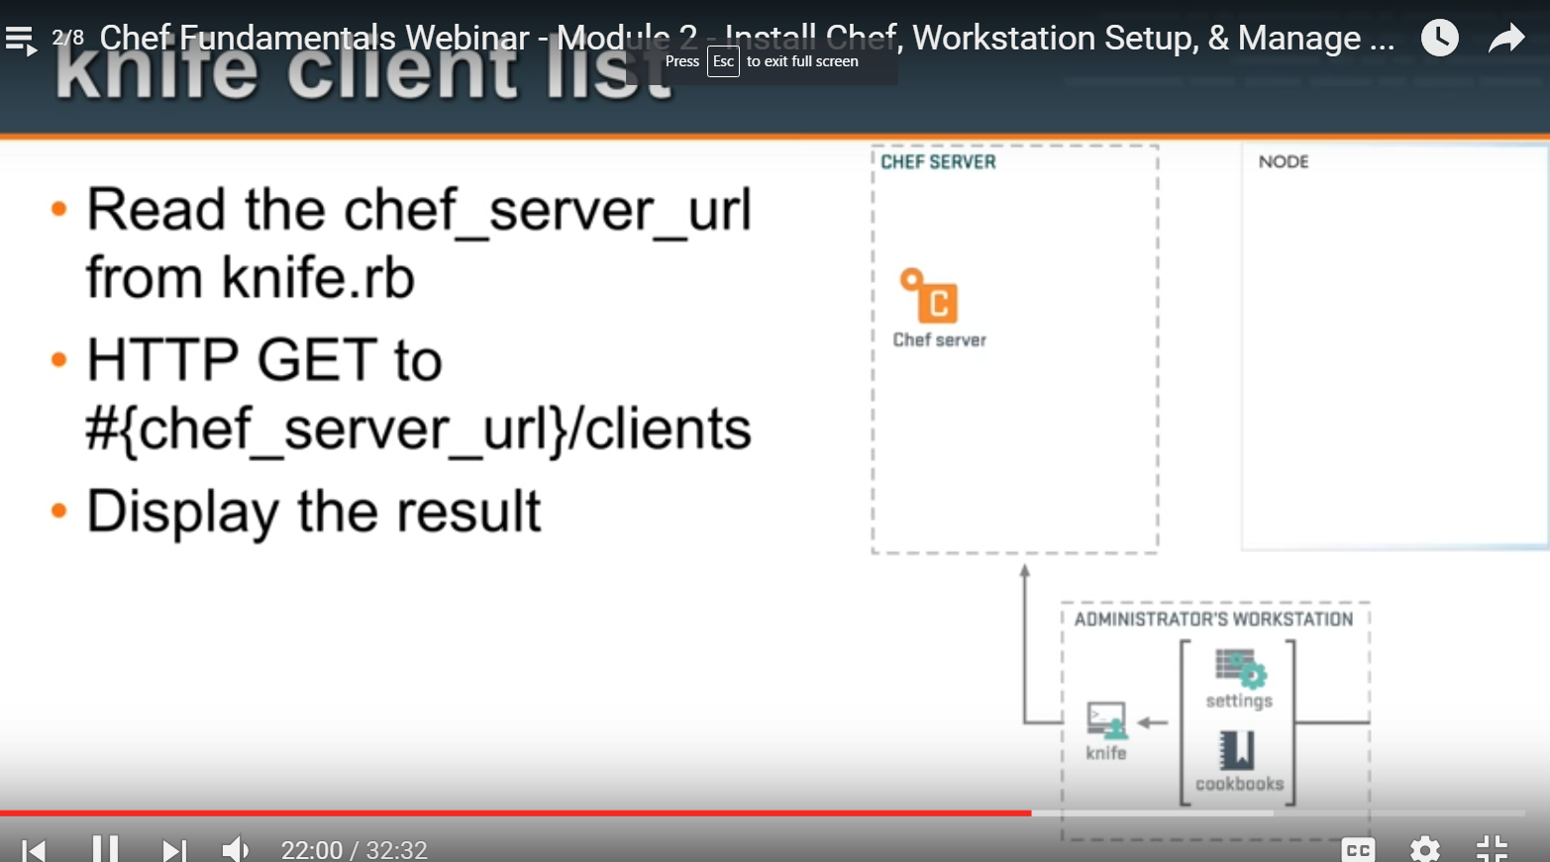

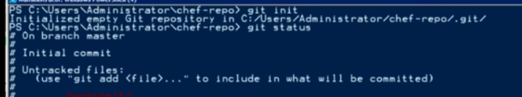

Git commit

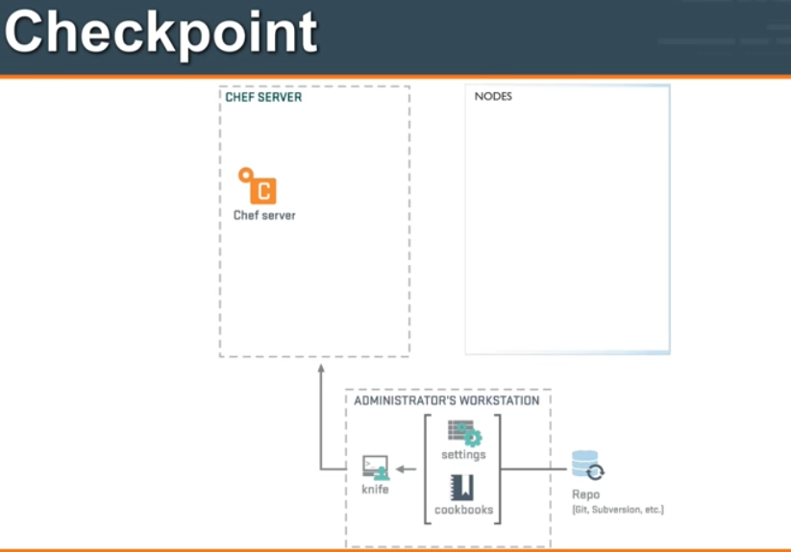

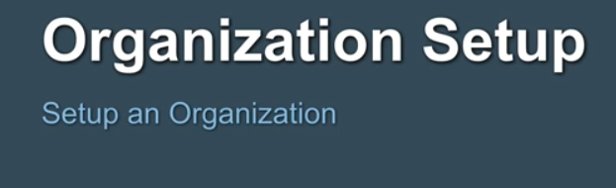

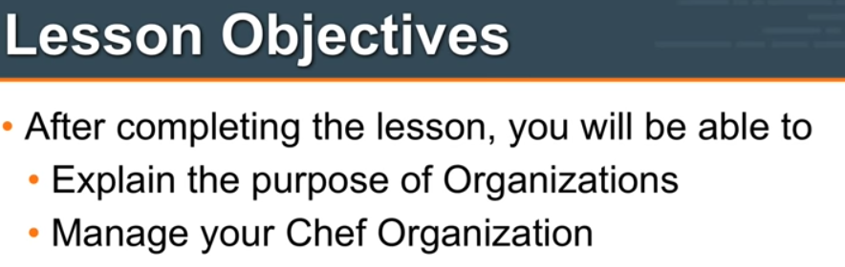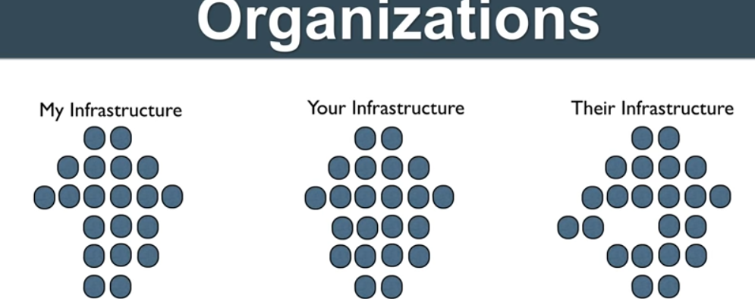

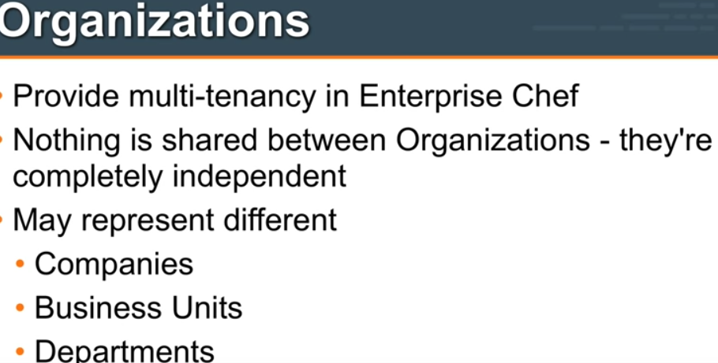

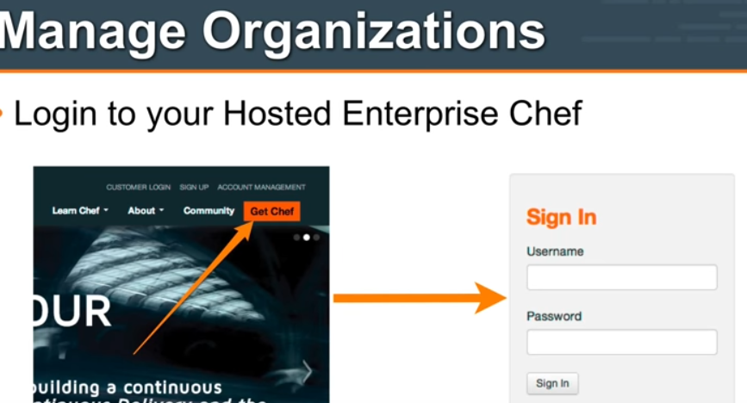

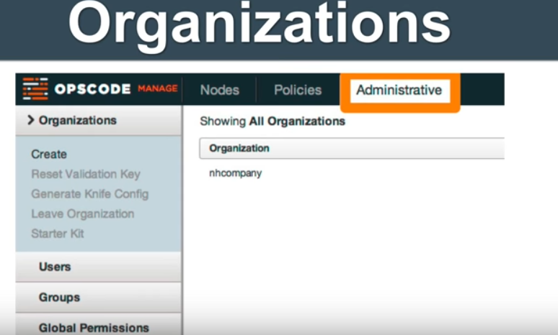

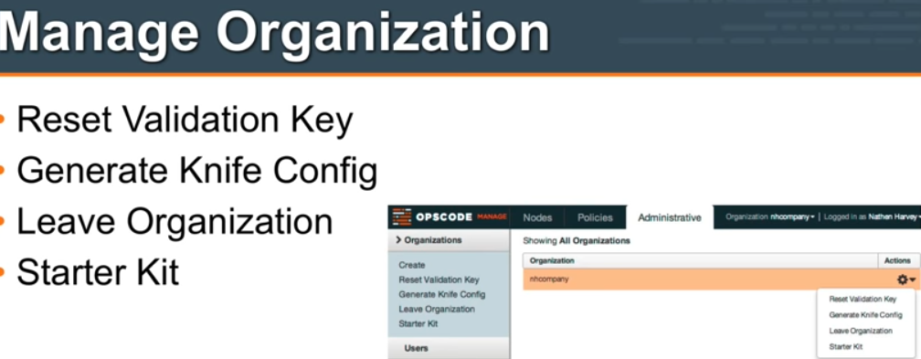

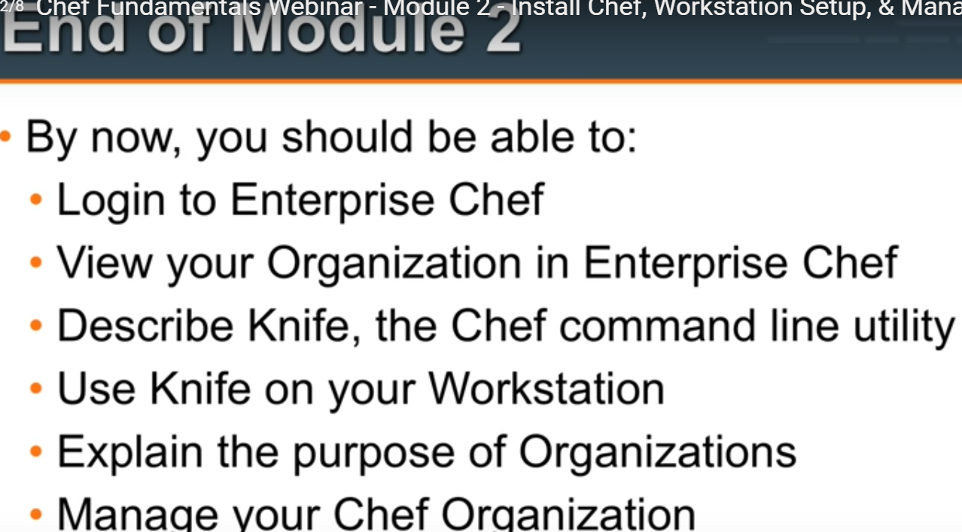

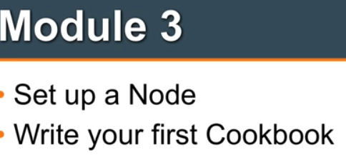

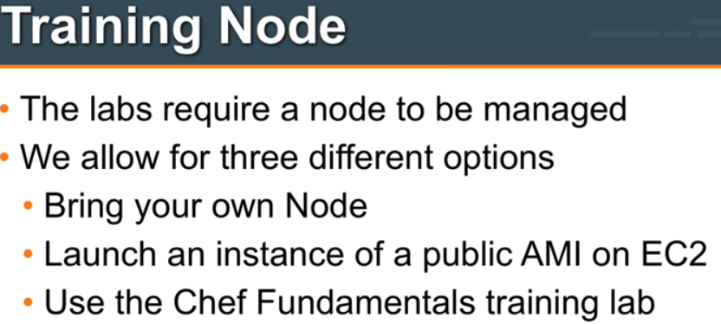

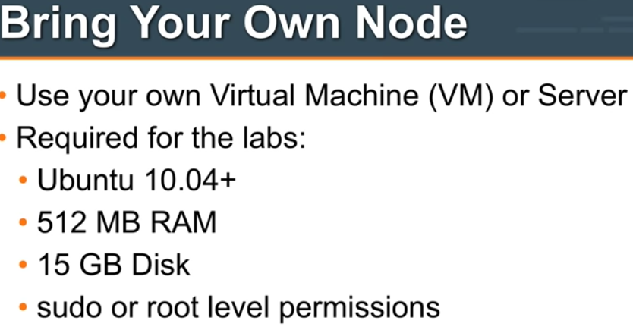

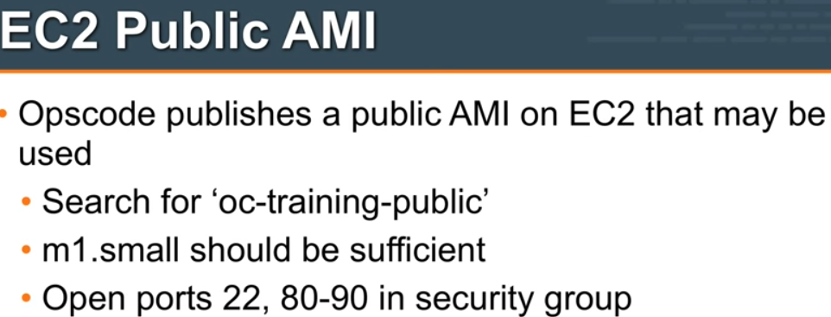

33333333333333333333333333333333333333333333333333333333

Chef Fundamentals Webinar - Training Lab Setup

333333333333333333333333333333333333333333333333333333333

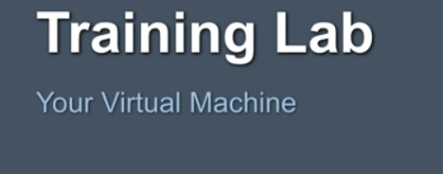

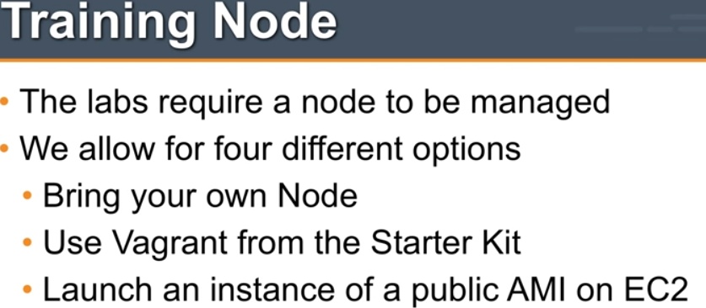

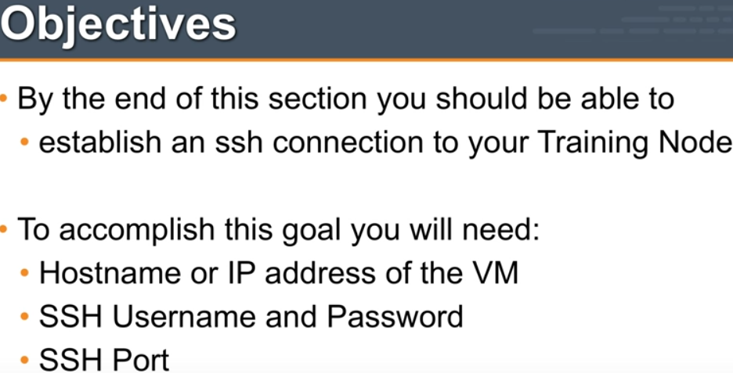

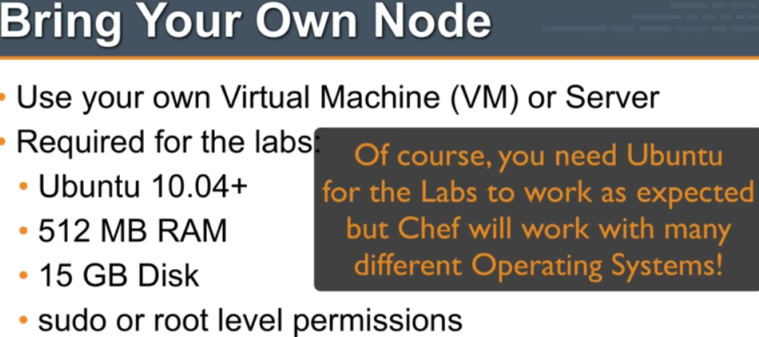

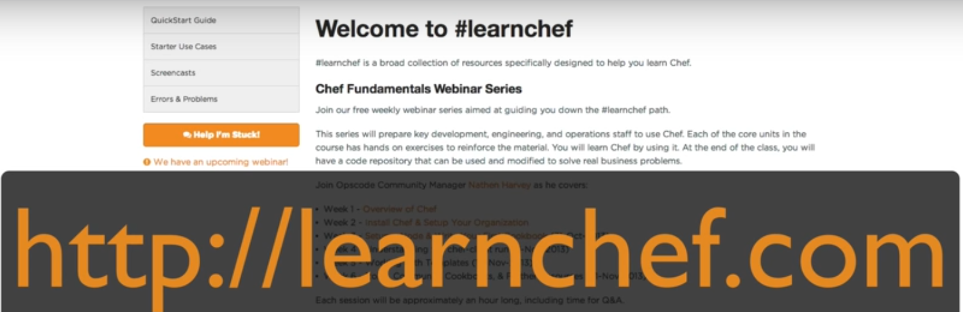

VAGRANT AS TRAINING LAB:

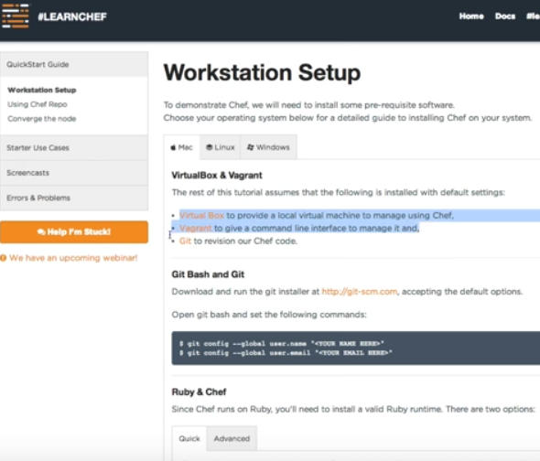

**444444444444444444444444444444444444444444444444444444444444444444444**

Chef Fundamentals Webinar - Module 3 - Set Up a Node & Write a Cookbook

44444444444444444444444444444444444444444444444444